Lewiston-Nez Perce County
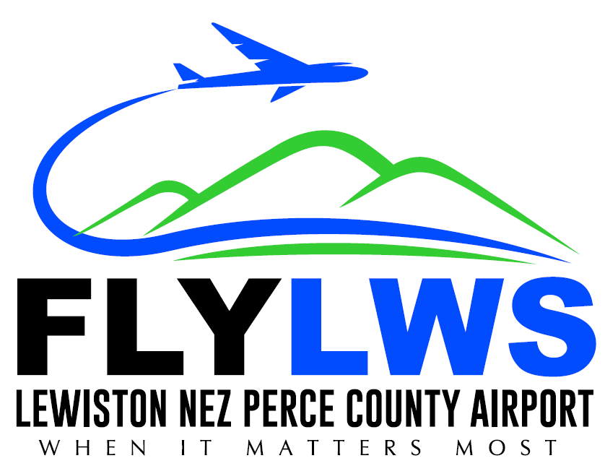
Regional Airport Authority
3632 Stearman St
Lewiston, Idaho 83501
Phone – 208-746-4471

2026

Meeting Schedule

Lewiston-Nez Perce County Regional Airport Authority Board of Commissioners

The Board of Commissioners meets in regular session on the third Tuesday of each month at *3:00 pm in the Conference Room of the Administration Building, 3632 Stearman St., Lewiston, ID 83501

The Board meeting dates for 2026 are scheduled as follows:

January 20, 2026
February 17, 2026
March 17, 2026
April 21, 2026
May 19, 2026
June 16, 2026
July 21, 2026
August 18, 2026
September 15, 2026
October 20, 2026
November 17, 2026
December 15, 2026

The Lewiston-Nez Perce County Regional Airport Authority Board reserves the right to alter this schedule as needed, consistent with Idaho Open Meeting Law requirements.

*Resolution 2020-39 Start time of the regular meetings changed to 3:00 p.m.

